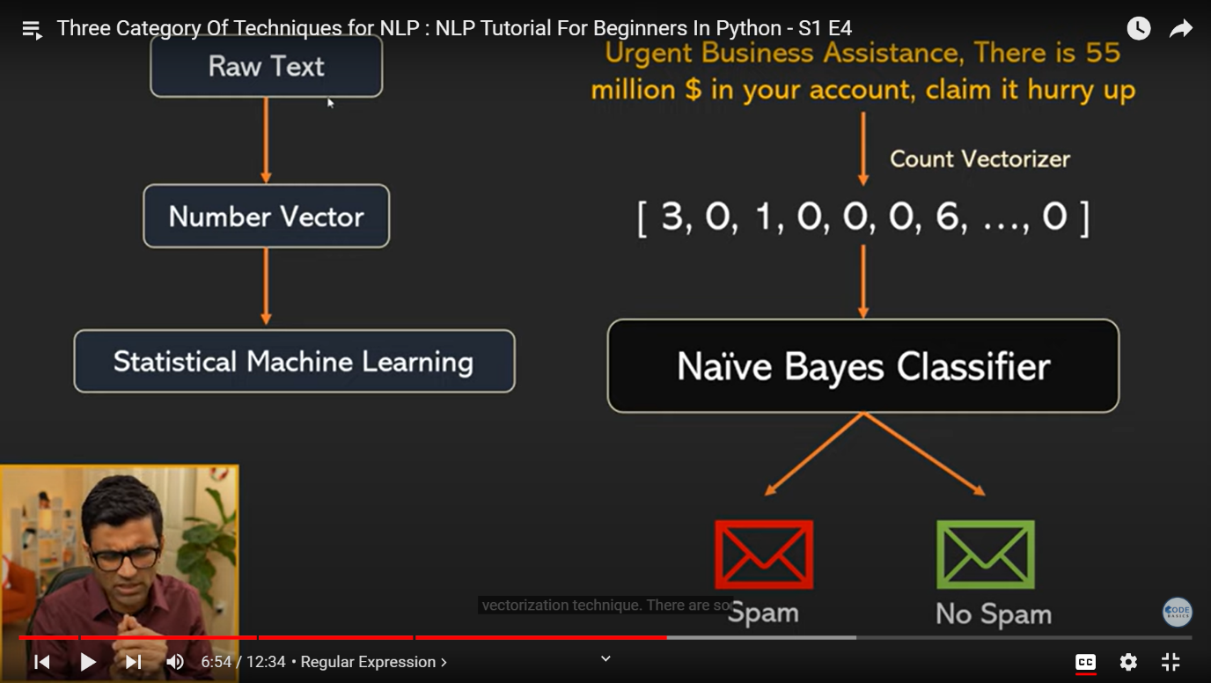NLP is use for google assistant and language translation , automatic news generate and communication and email spam and google search , amazon alexa .

NLP is a field in computer science and AI that gives machines an ability to understand human language better and to assist in language related tasks.

Python and spacy , genism, NLTK

NLP engineer means machine learning engineer

NLP is a not new field it is used in real case in the universe

1. Freely available pretrained models

Fast text, Tenser flow hub , Gpt3

Tenser flow (text problem domains, different model),

1. opensource ecosystem(python, spacy, genism, NLTK , scikit learn , hugging face, PY torch
2. cheap hard , cloud resource( a w s , azure, google cloud , r y zen)
3. Learning resource ( bootcamps , u demy , COURSERA , towards data science)
4. Huge investment by big tech(google , TPU , fast text, METO , amazon)

Regex for NLP:

1. Customer service chatbot.:( hello I am having an issue with my order #3433423433)

,( my order is having an issue , I was charged 50$ when online it says 40$)

, (I have a problem with y order number 34453423433)

[ Order any sequence of characters except digits sequence of digits

Order # 343342343333423433

Order 564596586256

Order number 465485458548 ]

Agent:

For Vari fication purpose can you tell me phone number and email id associated with this account?:

User:

Yes , phone number : 9334538905 , email id : [riteshk25808@gmail.com](mailto:riteshk25808@gmail.com)

Here it is ☹ (123)-567-8912, [abc@xyz.com](mailto:abc@xyz.com)

You ask lot of questions 54926598555 , [abc@xyz.com](mailto:abc@xyz.com)

Pattern is [XXXX@XXX.com](mailto:XXXX@XXX.com)

(XXX)-XXX-XXXX

XXXXXXXXXXXXX

Regular expressions 101:

Regular expressions

\d single digit

Test string: match single character

chat1 = 'codebasics: you ask to lot of questions 1235434347, abc@xyz.com'

chat2 = 'codebasics: here it is (123)-133-4544, abc@xyz.com'

chat3 = 'codebasics: yes, phone:1235434347 email: [abc@xyz.com](mailto:abc@xyz.com)

Regular expression:

\w

Text string :match any two word character:

chat1 = 'codebasics: you ask to lot of questions 1235434347, abc@xyz.com'

chat2 = 'codebasics: here it is (123)-133-4544, abc@xyz.com

chat3 = 'codebasics: yes, phone:1235434347 email:abc@gmail.com

regular expressions :

\d{10} ten digit selected

Text string

Chat1 = 'codebasics: you ask to lot of questions 1235434347, abc@xyz.com'

Chat2 = 'codebasics: here it is (123)-343-3433, abc@xyz.com'

Chat3 = 'codebasics: yes, phone:1235434347 email: [abc@xyz.com](mailto:abc@xyz.com)

regular expressions:

(\d{10}) , (\d{3}) , ascii character \(\d{3}\),

Text string:

Chat1 = 'codebasics: you ask to lot of questions 1235434347, abc@xyz.com'

Chat1 = 'codebasics: here it is (123)-343-3433, abc@xyz.com'

Chat3 = 'codebasics: yes, phone:1235434347 email: [abc@xyz.com](mailto:abc@xyz.com)’

Whole pattern:

Regular expressions:

\(\d{3}\)-\d{3}-\d{4}

chat1 = 'codebasics: you ask to lot of questions 1235434347, abc@xyz.com,9334538905'  
 chat2 = 'codebasics: here it is (123)-133-4544, abc@xyz.com'  
 chat3 = 'codebasics: yes, phone:1235434347 email:abc@gmail.com'

regular expressions

\(\d{3}\)

Text string:

Chat1 = 'codebasics: you ask to lot of questions 4354657675, abc@xyz.com'

Chat1 = 'codebasics: here it is (123)-343-3433, abc@xyz.com'

Chat3 = 'codebasics: yes, phone2234456678 , email: [abc@xyz.com](mailto:abc@xyz.com)’

Python Regulaar Expressions:

1. import re

Chat1 = 'codebasics: you ask to lot of questions 4354657675, abc@xyz.com,9334538905’

Chat1 = 'codebasics: here it is (123)-343-3433, abc@xyz.com'

Chat3 = 'codebasics: yes, phone2234456678 , email: [abc@xyz.com](mailto:abc@xyz.com)’

Pattern = ‘\d{10}’

Matches = re . findall(pattern, chat1)

Print(matches)

Output: ['1235434347', '9334538905']

2 . import re

Chat1 = 'codebasics: you ask to lot of questions 4354657675, abc@xyz.com,9934538905’

Chat1 = 'codebasics: here it is (123)-343-3433, abc@xyz.com'

Chat3 = 'codebasics: yes, phone2234456678 , email: [abc@xyz.com](mailto:abc@xyz.com)’

Pattern= '\d{10}|\(\d{3}\)-\d{3}-\d{4}'

Matches = re . findall(pattern, chat1)

Print(matches)

Output: ['1235434347', '9334538905']

3 . . import re

Chat1 = 'codebasics: you ask to lot of questions 4354657675, abc@xyz.com,9934538905’

Chat1 = 'codebasics: here it is (123)-343-3433, abc@xyz.com'

Chat3 = 'codebasics: yes, phone2234456678 , email: [abc@xyz.com](mailto:abc@xyz.com)’

Pattern= '\d{10}|\(\d{3}\)-\d{3}-\d{4}'

Matches = re . findall(pattern, chat2)

Print(matches)

Output:

['(123)-133-4544']

4 . . import re

Chat1 = 'codebasics: you ask to lot of questions 4354657675, abc@xyz.com,9934538905’

Chat1 = 'codebasics: here it is (123)-343-3433, [abc@xyz.com](mailto:abc@xyz.com)

Chat3 = 'codebasics: yes, phone2234456678 , email: [abc@xyz.com](mailto:abc@xyz.com)’

Pattern= '\d{10}|\(\d{3}\)-\d{3}-\d{4}'

Matches = re . findall(pattern, chat3)

Print(matches)

Output: ['1235434347']

Regular expressions :

[a-z]@

Text string :

chat1 = 'codebasics: you ask to lot of questions 1235434347, abc@xyz.com'

chat2 = 'codebasics: here it is (123)-133-4544, abX_82@xyz.com'c

chat3 = 'codebasics: yes, phone:1235434347 email: [abc@xyz.com](mailto:abc@xyz.com)’

Regular expressions:

[a-z]*@

Text string :

chat1 = 'codebasics: you ask to lot of questions 1235434347, abc@xyz.com'

chat2 = 'codebasics: here it is (123)-133-4544, abX_82@xyz.com'

chat3 = 'codebasics: yes, phone:1235434347 email: [abc@xyz.com](mailto:abc@xyz.com)’

Regular expressions:

[a-z0-9]*@

Text string :

chat1 = 'codebasics: you ask to lot of questions 1235434347, abc@xyz.com'

chat2 = 'codebasics: here it is (123)-133-4544, abX_82@xyz.com'

chat3 = 'codebasics: yes, phone:1235434347 email: [abc@xyz.com](mailto:abc@xyz.com)’

Regular expressions:

[a-z0-9A-Z]*@

Text string :

chat1 = 'codebasics: you ask to lot of questions 1235434347, abcA@xyz.com'

chat2 = 'codebasics: here it is (123)-133-4544, abX_82@xyz.com'

chat3 = 'codebasics: yes, phone:1235434347 email: [abc@xyz.com](mailto:abc@xyz.com)’

Regular expressions:

[a-z0-9A-Z_]*@

Text string:

chat1 = 'codebasics : you ask to lot of questions 1235434347, abcA@xyz.com'

chat2 = 'codebasics : here it is (123)-133-4544, abX_82@xyz.com'

chat3 = 'codebasics : yes, phone:1235434347 email: [abc@xyz.com](mailto:abc@xyz.com)’

Regular expressions:

[a-z0-9A-Z_]*@ _ for abX_

Text string:

chat1 = 'codebasics : you ask to lot of questions 1235434347, abcA@xyz.com'

chat2 = 'codebasics : here it is (123)-133-4544, abX_82@xyz.com'

chat3 = 'codebasics : yes, phone:1235434347 email: [abc@xyz.com](mailto:abc@xyz.com)’

Regular expressions:

[a-z0-9A-Z_]*@[a-z0-9A-Z_]*

Text string:

chat1 = 'codebasics : you ask to lot of questions 1235434347, abcA@xyz.com'

chat2 = 'codebasics : here it is (123)-133-4544, abX_82@xyz.com'

chat3 = 'codebasics : yes, phone:1235434347 email: [abc@xyz.com](mailto:abc@xyz.com)’

Regular expressions:

[a-z0-9A-Z_]*@[a-z0-9A-Z_]*\.

Text string:

chat1 = 'codebasics : you ask to lot of questions 1235434347, abcA@xyz.com'

chat2 = 'codebasics : here it is (123)-133-4544, abX_82@xyz.com'

chat3 = 'codebasics : yes, phone:1235434347 email: [abc@xyz.com](mailto:abc@xyz.com)’

chat3 = 'codebasics : yes, phone:1235434347 email: [abc@xyz.com](mailto:abc@xyz.com)’

Regular expressions:

[a-z0-9A-Z_]*@[a-z0-9A-Z_]*\.[a-z0-9A-Z_]*

Text string:

chat1 = 'code basics : you ask to lot of questions 1235434347, abcA@xyz.com'

chat2 = 'code basics : here it is (123)-133-4544, abX_82@xyz.com'

chat3 = 'code basics : yes, phone:1235434347 email: [abc@xyz.com](mailto:abc@xyz.com)’

python code:

1. import re

chat1 = 'codebasics: you ask to lot of questions 1235434347, abcA@xyz.com'

chat2 = 'codebasics: here it is (123)-133-4544, abX_82@xyz.com'

chat3 = 'codebasics: yes, phone:1235434347 email: [abc@xyz.com](mailto:abc@xyz.com)'

pattern = ‘[a-z0-9A-Z_][*@[a-z0-9A-Z_]*\.[a-z0-9A-Z_]*](mailto:*@[a-z0-9A-Z_]*\.%5ba-z0-9A-Z_%5d*)’

matches = re . find all(pattern , chat1)

print(matches)

outputs: ['abcA@xyz.com']

2 . import re

chat1 = 'codebasics: you ask to lot of questions 1235434347, abcA@xyz.com'

chat2 = 'codebasics: here it is (123)-133-4544, abX_82@xyz.com'

chat3 = 'codebasics: yes, phone:1235434347 email: [abc@xyz.com](mailto:abc@xyz.com)'

pattern = ‘[a-z0-9A-Z_][*@[a-z0-9A-Z_]*\.[a-z0-9A-Z_]*](mailto:*@[a-z0-9A-Z_]*\.%5ba-z0-9A-Z_%5d*)’

matches = re . find all(pattern , chat1)

print(matches)

outputs : ['abcX_82@xyz.com']

3 . . import re

chat1 = 'codebasics: you ask to lot of questions 1235434347, abcA@xyz.com'

chat2 = 'codebasics: here it is (123)-133-4544, abX_82@xyz.com'

chat3 = 'codebasics: yes, phone:1235434347 email: [abc@xyz.com](mailto:abc@xyz.com)'

pattern = ‘[a-z0-9A-Z_][*@[a-z0-9A-Z_]*\.[a-z0-9A-Z_]*](mailto:*@[a-z0-9A-Z_]*\.%5ba-z0-9A-Z_%5d*)’

matches = re . find all(pattern , chat1)

print(matches)

outputs : ['abc@gmail.com']

